**Profile**

A BCA graduate aspiring to gain a full-time position in a reputed company. Gained extensive experience in web-app development, front-end development, and deployment through various projects. A highly motivated and hardworking individual skilled in Java, SQL, HTML, CSS and JavaScript along with some front-end frameworks like Bootstrap and React.js.

Seeking a position to utilize the gained skills and experience to positively contribute to the company.

**CONTACT**





**LINKS**

* [LinkedIn](https://www.linkedin.com/in/salonika-panda?lipi=urn%3Ali%3Apage%3Ad_flagship3_people%3B2SpK4SqlRRKlZDG73RCfQw%3D%3D)
* [GitHub](https://github.com/SalonikaPanda?tab=overview&from=2023-12-01&to=2023-12-31)
* [Portfolio](https://salonikapanda.github.io/Portfolio/)

**INTERESTS**

* Reading
* Singing
* Coding

**RELEVANT COURSES**

* DBMS
* Data Structures and Algorithms
* Operating System
* Computer Networks

**TECHNICAL SKILLS**

* HTML5
* CSS3
* Javascript
* SQL
* Basics of Java
* Bootstrap5

**SOFT SKILLS**

* Communication
* Team work
* Leadership
* Presentation

**PROJECTS**

* **Personal Portfolio** : Created a personal portfolio website using HTML, CSS and JavaScript.
* **Snake Game :** Developed a Snake Game website using HTML, CSS, and JavaScript.
* **Real time clock :** Created a clock website which shows the current date and time.

**EDUCATION**

* **BCA | Centurion University of Technology and Management, Bolangir | 2021-2024**

Bachelor degree in Computer Applications with 9.7 CGPA

* **XII | Vikash Residential School, Bhawanipatna | 2019-2021**

Passed 12th with 83%

* **X | Odisha Adarsha Vidyalaya | 2019**

Passed 10th with 84%

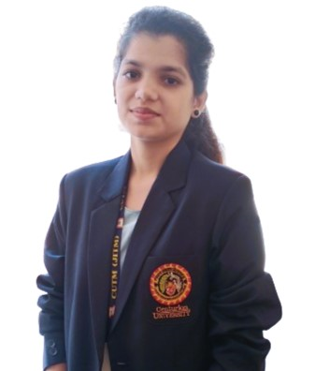

**SALONIKA PANDA**

salonikapanda04@gmail.com

+91 8327741393